Git & Github 22/10/26

1 . Create a Github Account.
Step
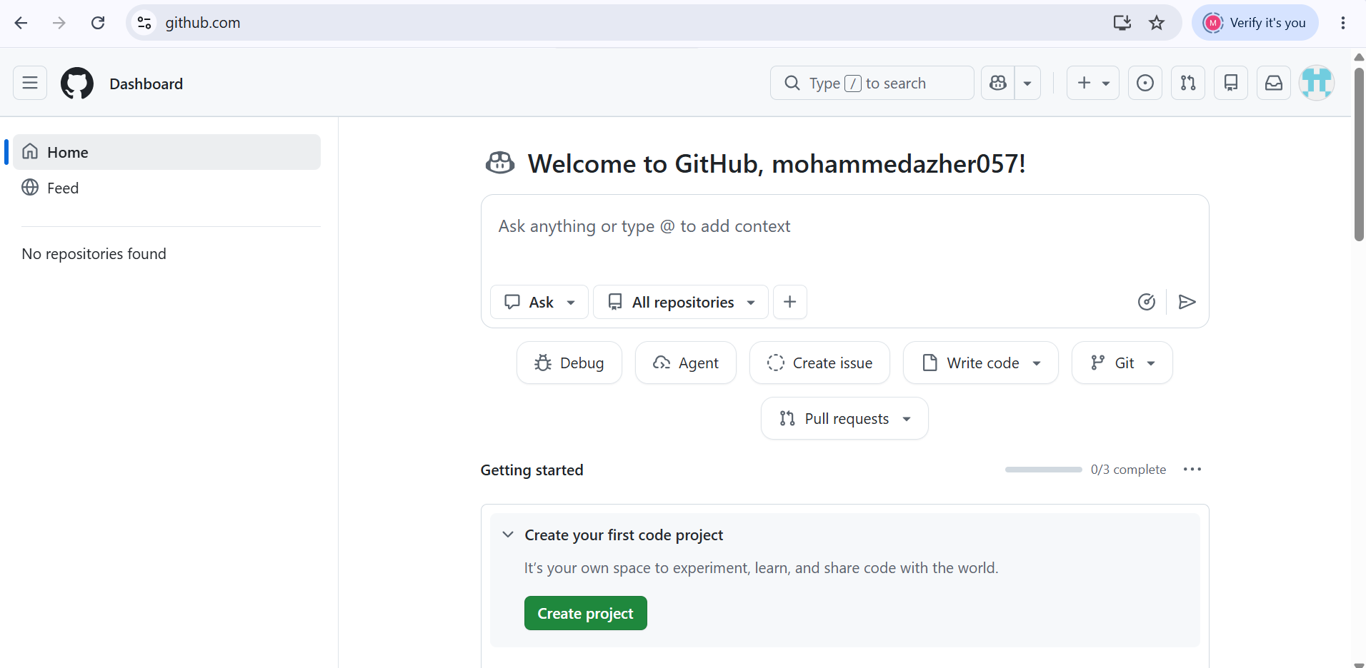
2 . Set up MFA (Multi-Factor Authentication) for the GitHub account using a mobile app.
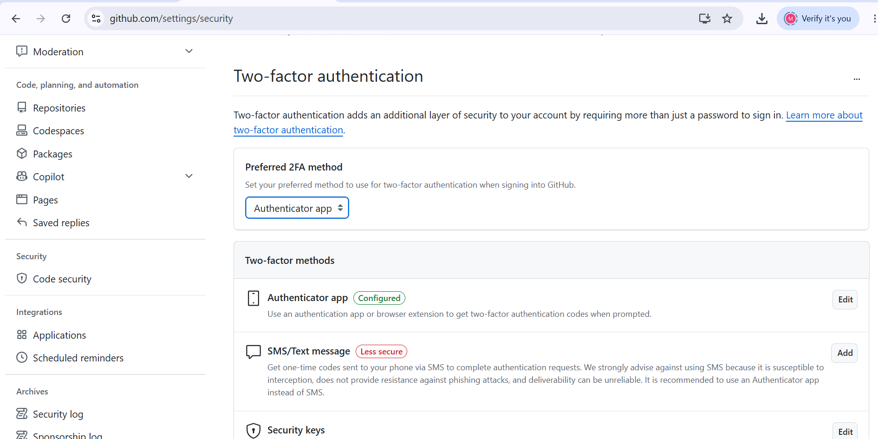
3 . Execute all commands shown in the video.
Steps
- git –version : Check Git installation
- . git init = Initialize a Git repository.
3 . $ git config --global user.name "Shahzain"
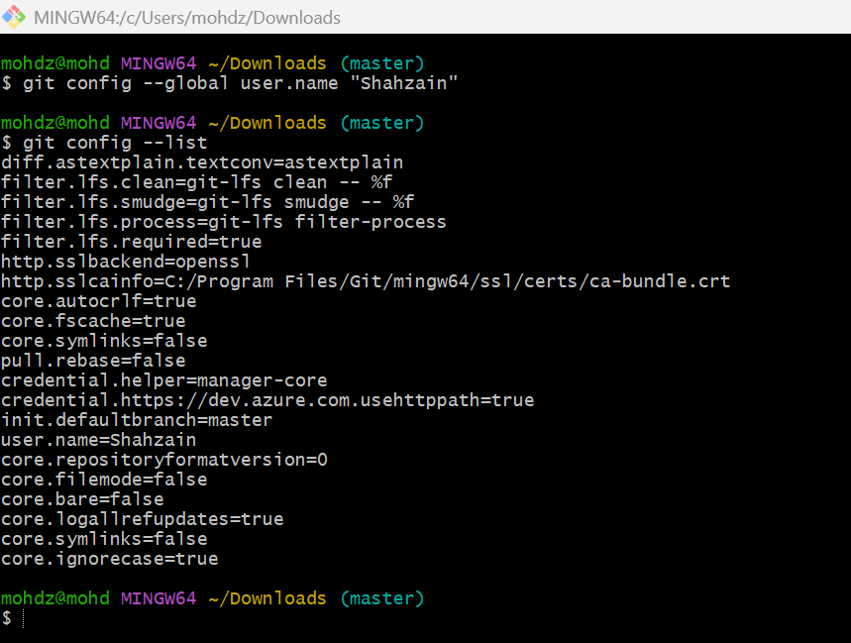
4 . Git email configuration
: git config --global user.email
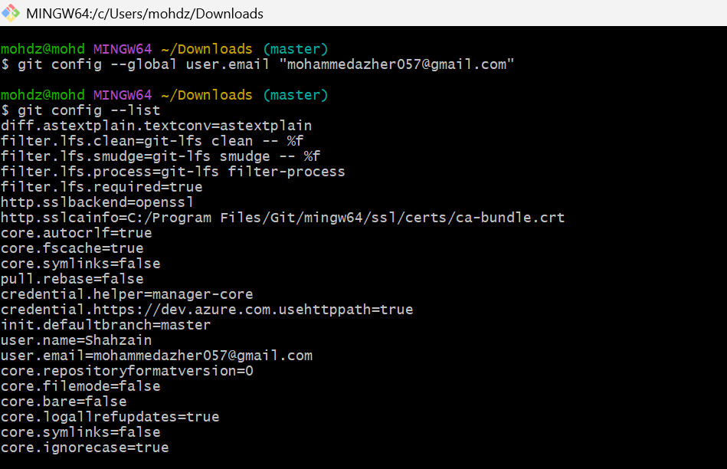
5 This command displays your current Git configuration settings.
: git config –list
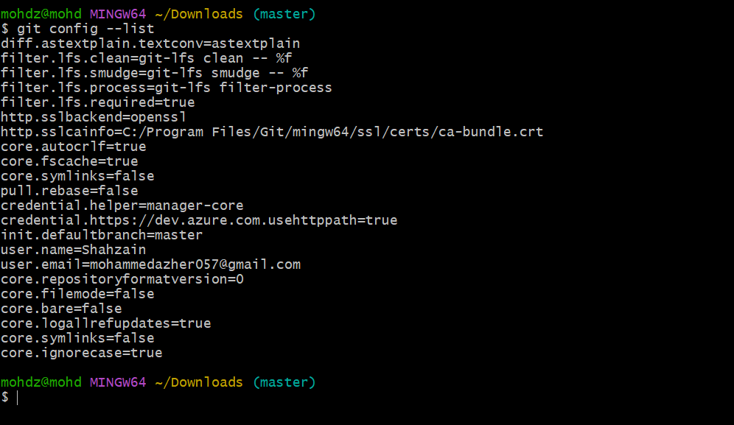
6 git status
Is used to check tracked or untracked files
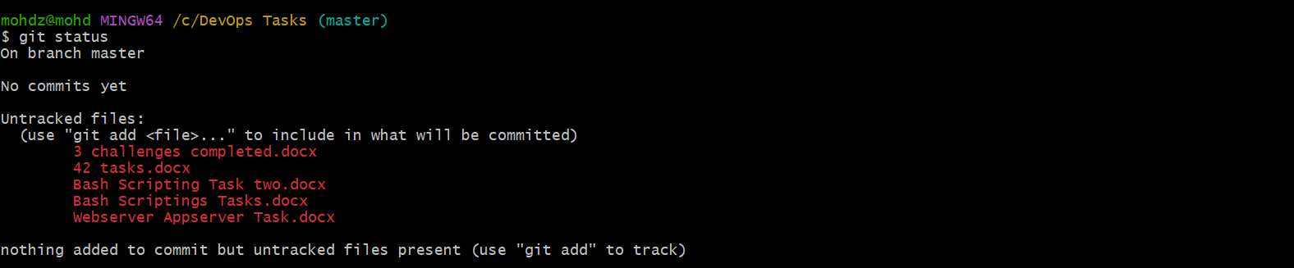
7 . Adds all new and modified files in the current directory to Git's staging area, ready to commit.
Git add .
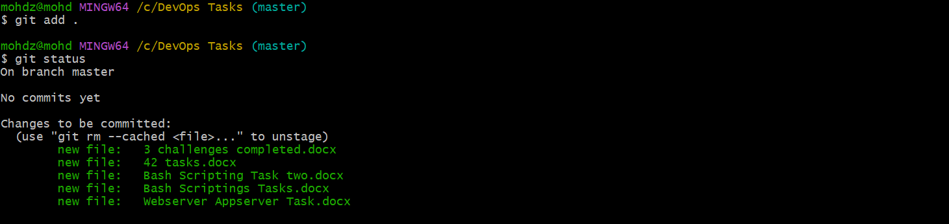
8 . First, I created three files named alphabet, apple, and gava using the touch command. Then, I used git status to check which files were tracked or untracked in Git.
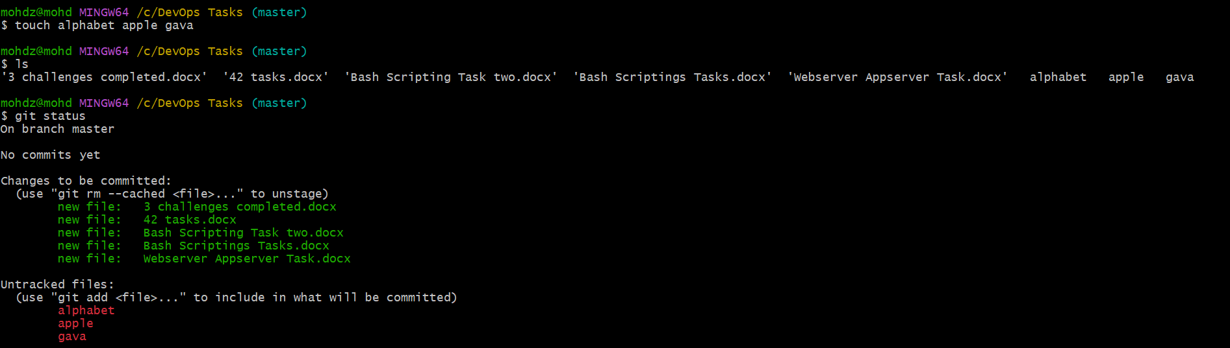
First, I tried to commit the tracked files using the command git commit -m "Added files to the project". Then, I used the git add . command to stage all the files. Finally, I committed the staged files using git commit -m "Added files to the project".
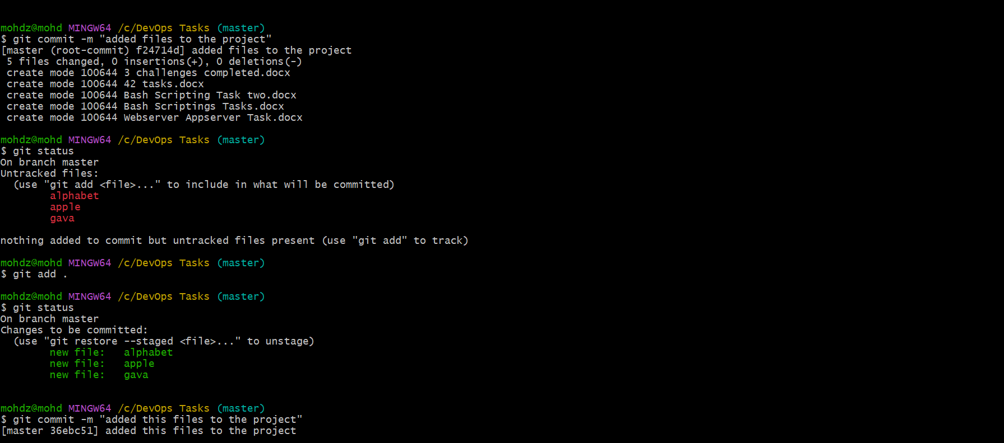
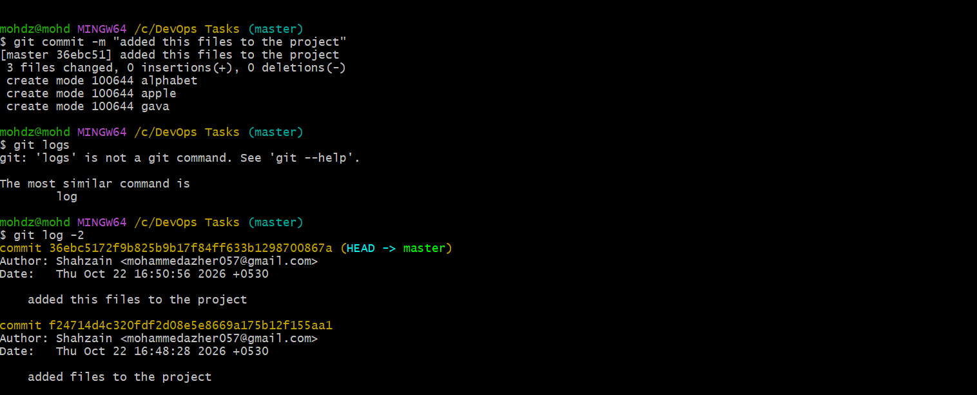
9 git log used log check commit id
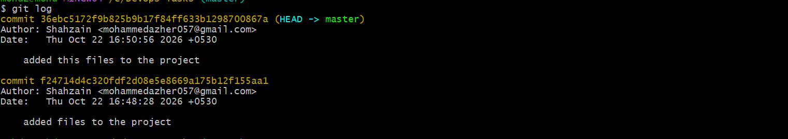
10 git reset is used to undo changes in the Git staging area
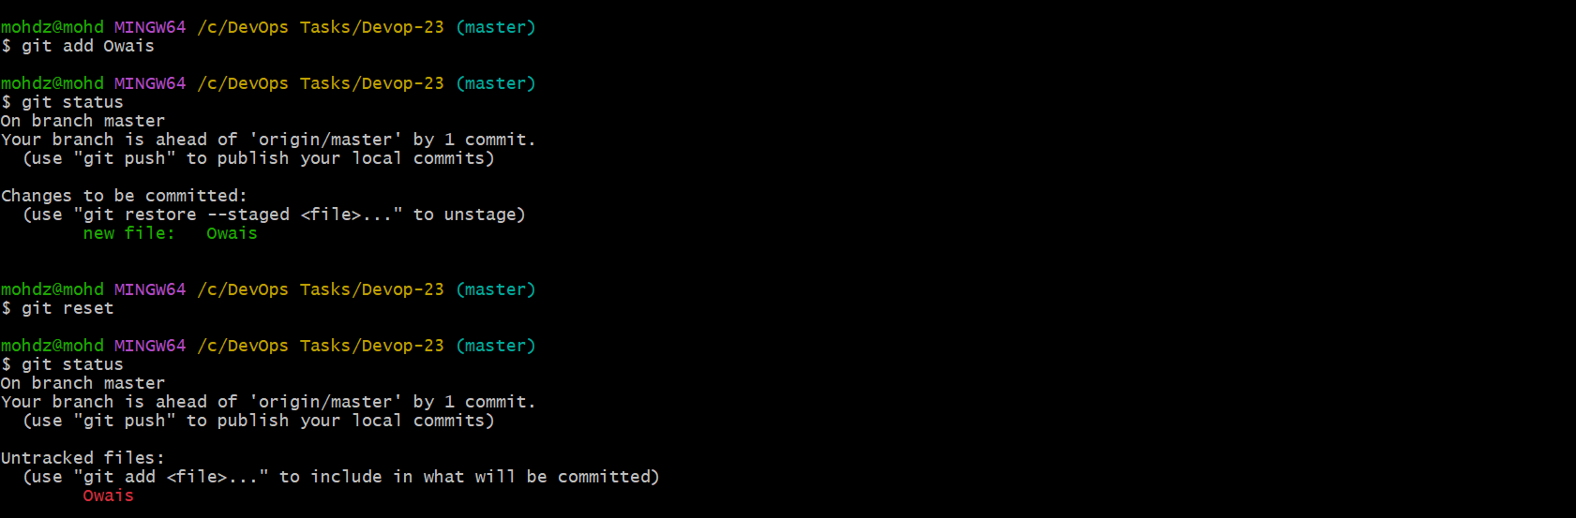
11 git revert ( commit id ) is used to undo a previous commit by creating a new commit that reverses its changes.
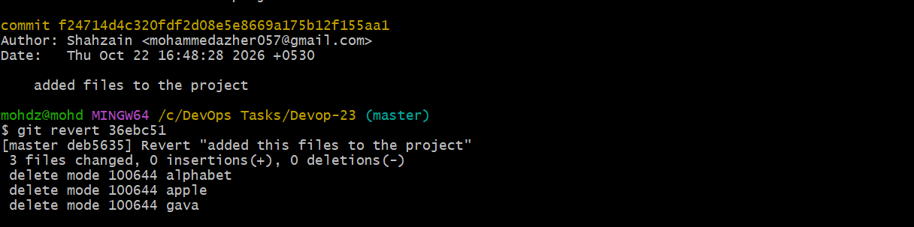
12 git clone is used to copy a remote Git repository to your local computer.
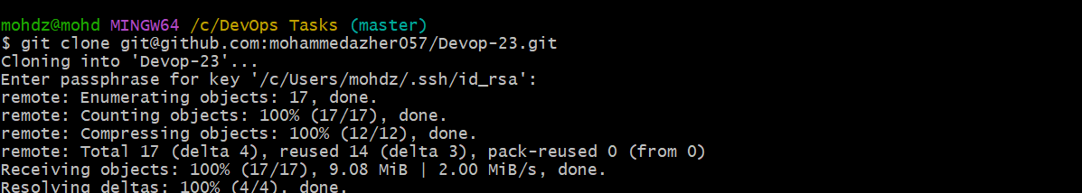
13 git pull is used to download the latest changes from a remote repository and integrate them into your current local branch.
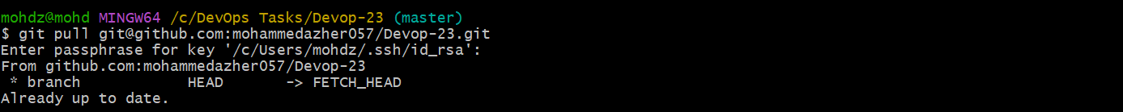
14 git remote add orgin is used to connect your local Git repository to a remote repository, such as GitHub.
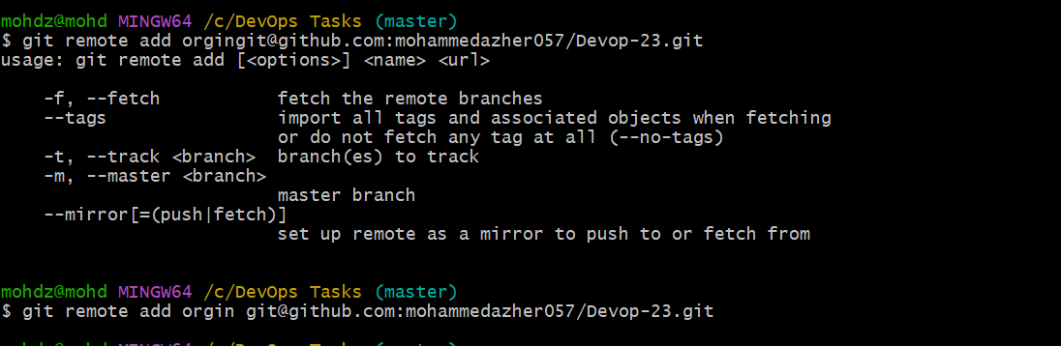
15 git remote -v is used to display the remote repositories connected to your local Git repository, along with their URLs
16 ssh-keygen is used to generate SSH key pairs (a public key and a private key) for secure authentication.
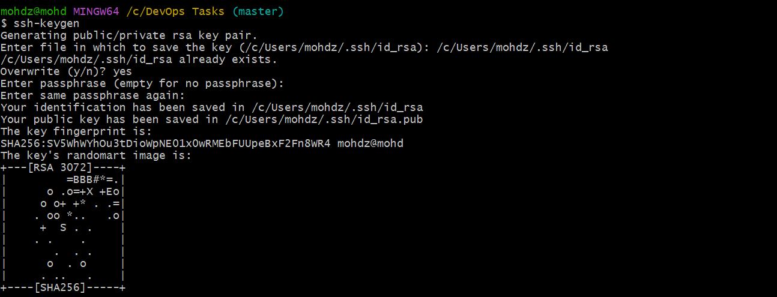
/c/Users/mohdz/.ssh/id_rsa.pub. this is the path of public ssh-keygen copy the publice keygen then I open github open settings go to ssh and GpGkeys then I was paste in ssh section
17 git push -u orgin master is used to upload local commits from the master branch to the remote repository on GitHub and set the upstream branch.
